**SERVICE INVENTORY MODULE - USER STORIES**

**Internal API**

For internal access

1. Once you enter the dashboard, you can see internal service inventory list. Your action is you can only view the details by clicking the button View. You can also search the inventory list by using the Search bar. You can also customize your view by choosing the drop down for items per page.

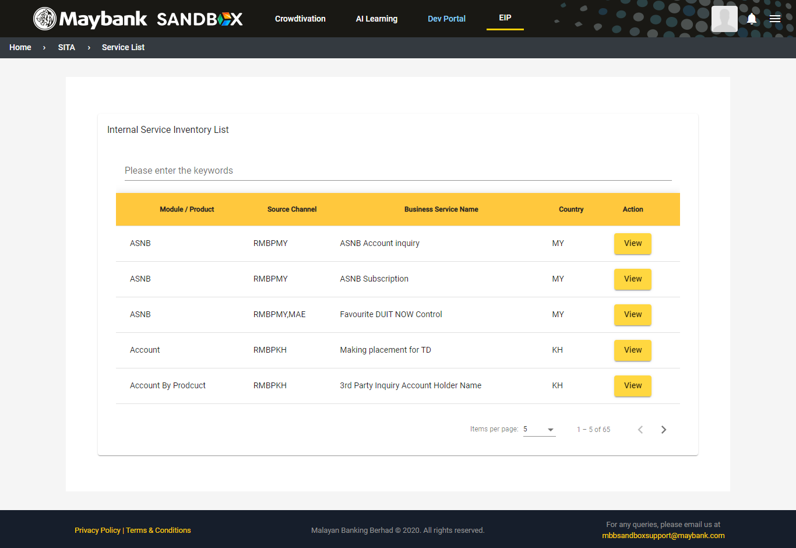

1. Once you click the button View, the service details will be shown. You can report any issues by clicking Report Issue button or submit your feedback via the Feedback button. Back button will redirect you to the internal inventory list page.

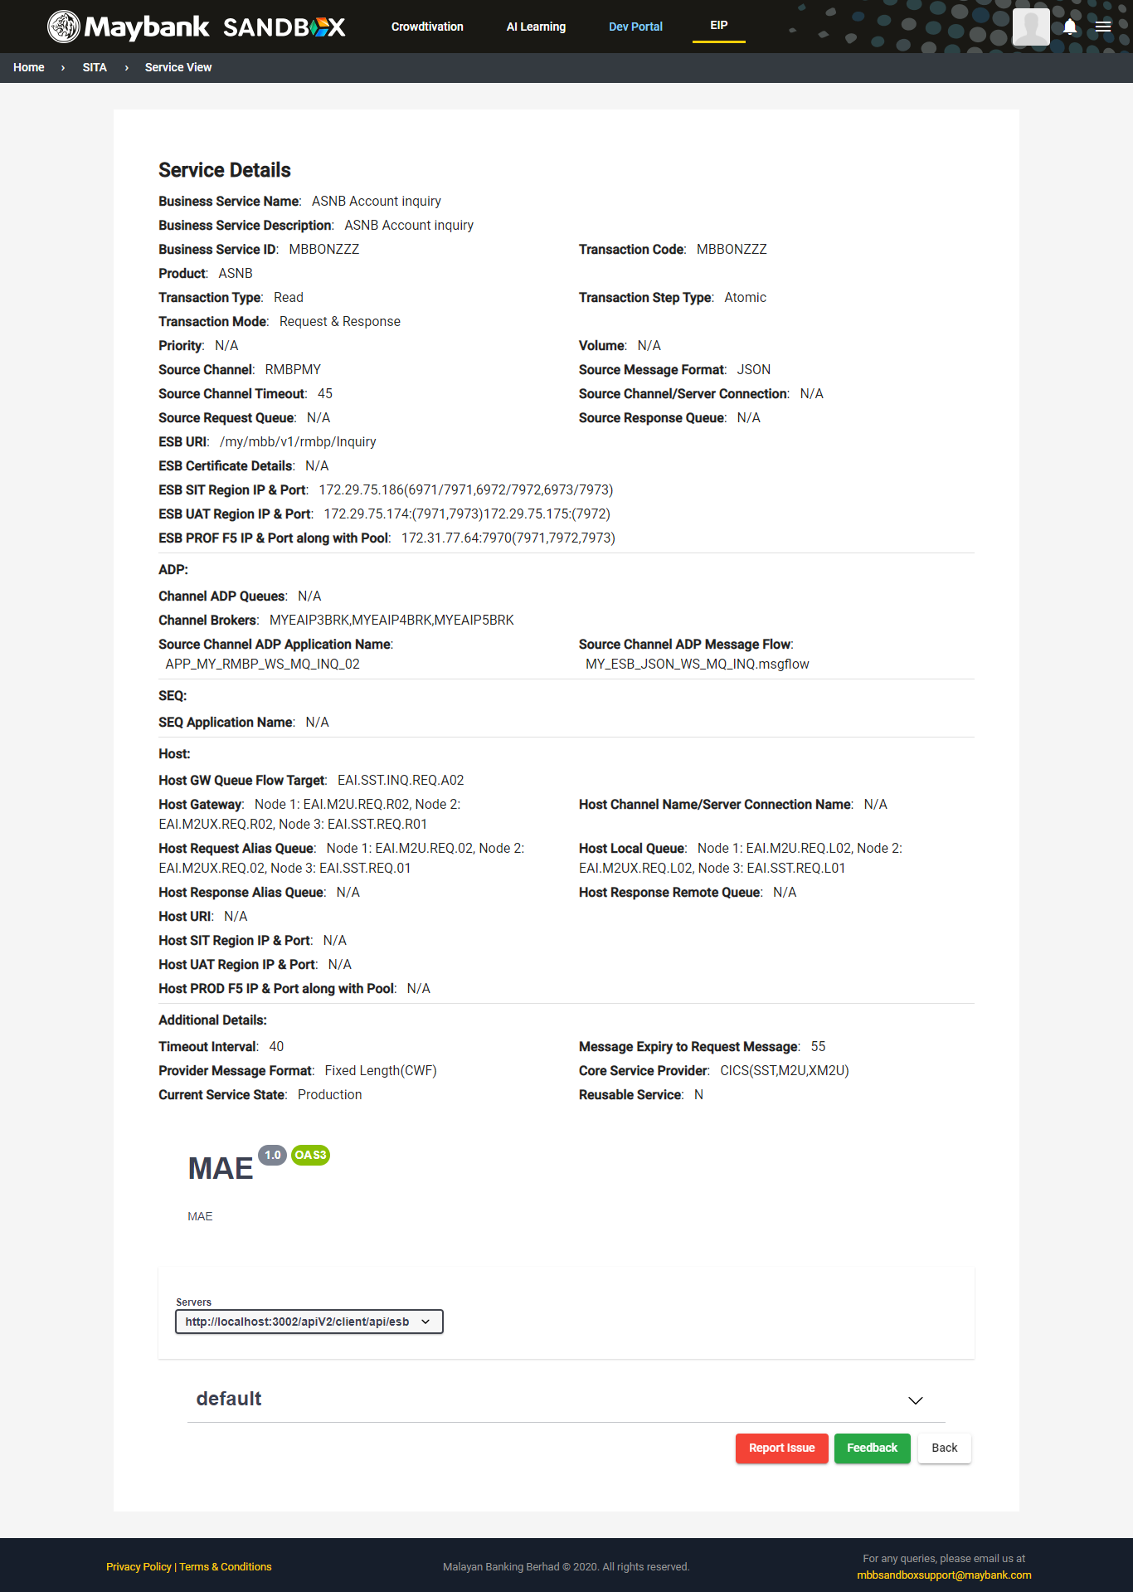

For admin

1. Once you enter the dashboard, you can see internal service inventory list and also the pending approval. Your action is you can view the details by clicking the button View. You can also search the inventory list by using the Search bar. You can also customize your view by choosing the drop down for items per page.

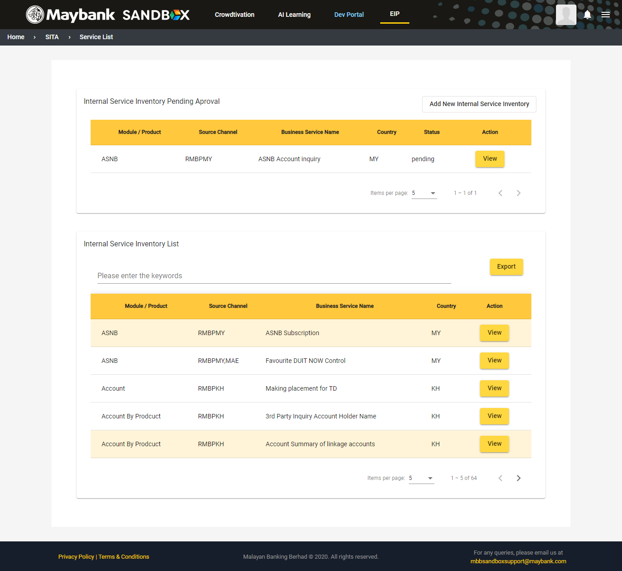

1. Once you click the button View, all the service details will be shown. Admin can reject or approve the request here. Admin can duplicate the whole detail contents by clicking the Create as New button. You can also edit any contents of the details via the Edit button. You can report any issues by clicking Report Issue button or submit your feedback via the Feedback button. Back button will redirect you to the internal inventory list page.

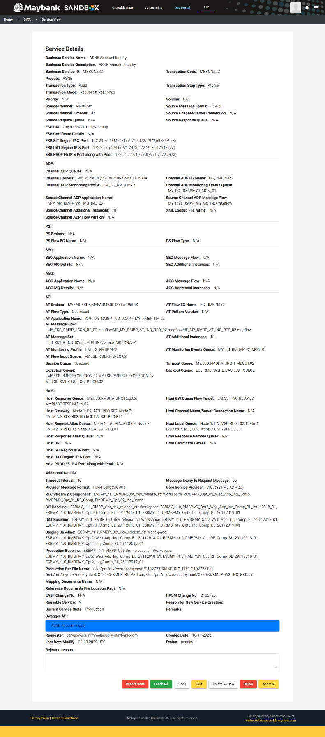

For team access

1. Once you enter the dashboard, you can see internal service inventory list and rejected request. Your action is you can view the details by clicking the button View or you can add new internal service inventory. You can also search the inventory list by using the Search bar. You can also customize your view by choosing the drop down for items per page.

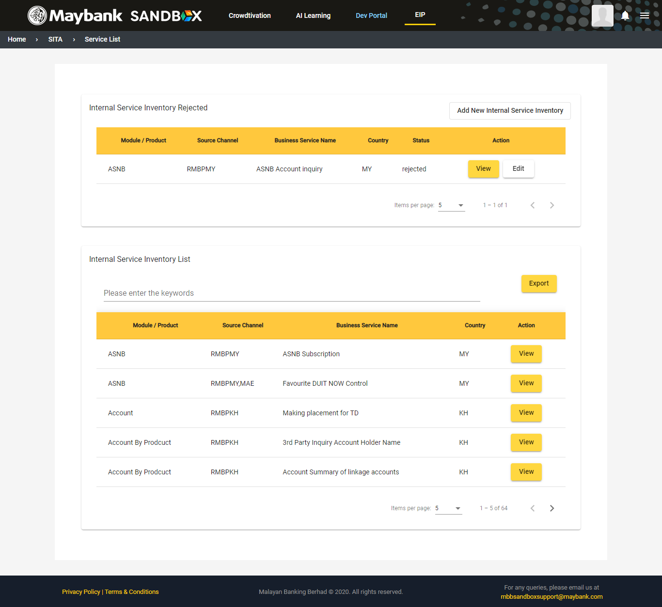

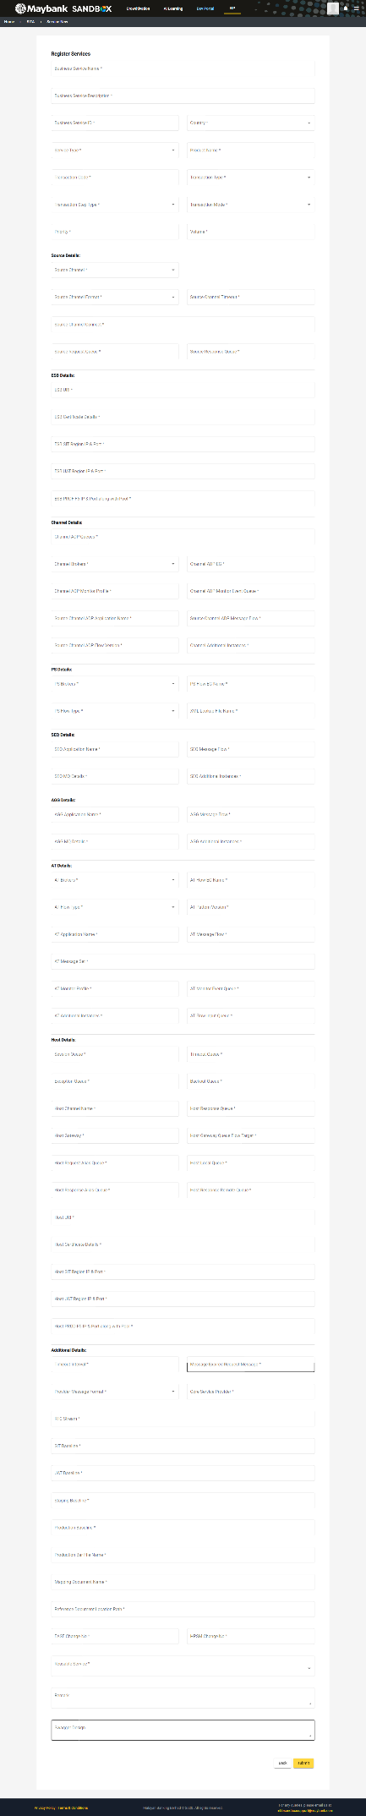

1. Once you click the button View, all the service details will be shown. You can duplicate the whole detail contents by clicking the Create as New button. You can also edit any contents of the details via the Edit button. You can report any issues by clicking Report Issue button or submit your feedback via the Feedback button. Back button will redirect you to the internal inventory list page.

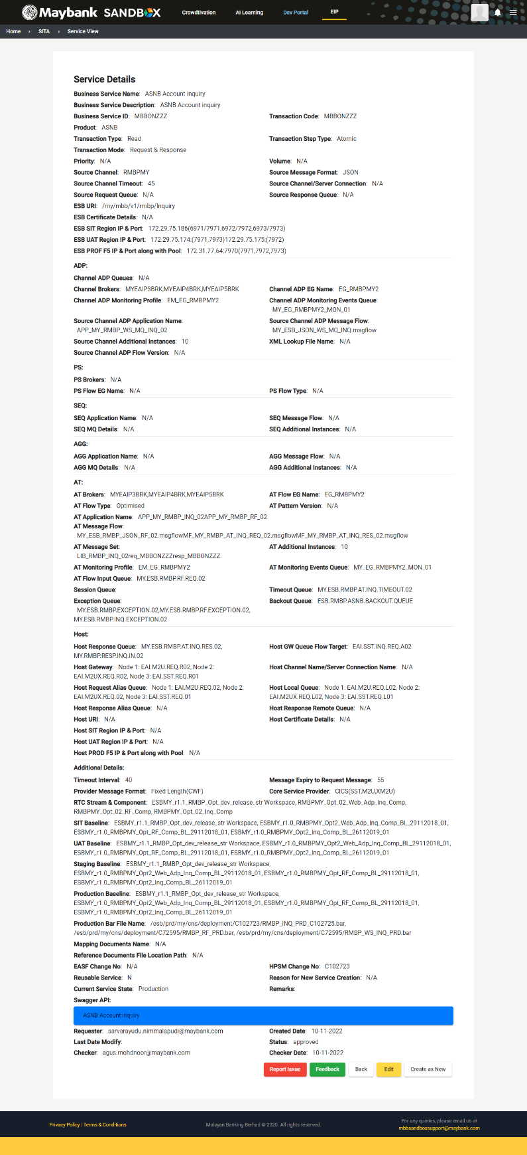

**External Services**

For internal access

1. Once you enter the dashboard, you can see external service inventory list. Your action is you can only view the details by clicking the button View. You can also search the inventory list by using the Search bar. You can also customize your view by choosing the drop down for items per page.

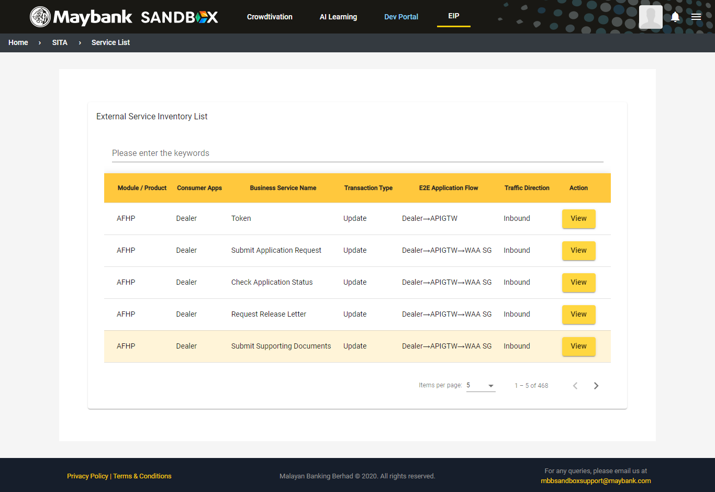

1. Once you click the button View, the service details will be shown. You can report any issues by clicking Report Issue button or submit your feedback via the Feedback button. Back button will redirect you to the internal inventory list page.

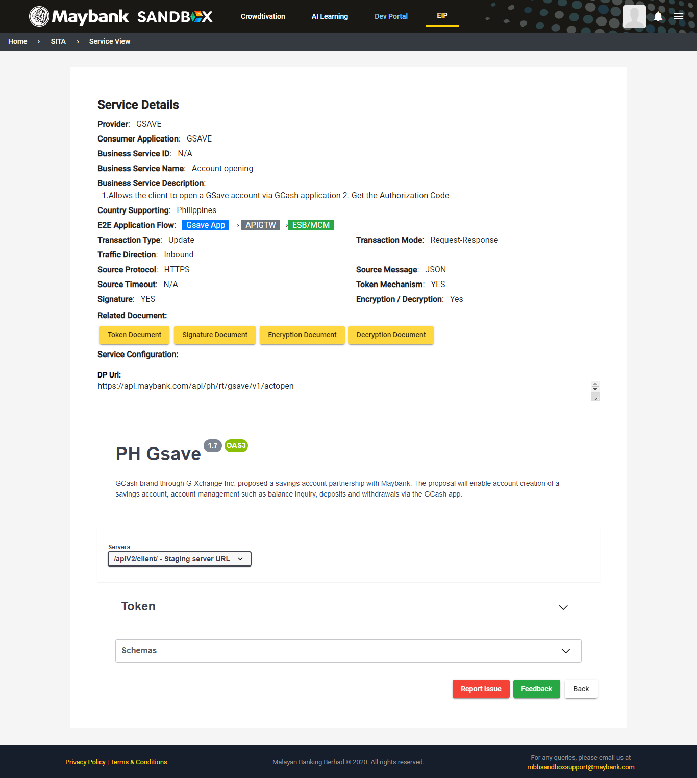

For admin

1. Once you enter the dashboard, you can see external service inventory list and also the pending approval. Your action is you can view the details by clicking the button View. You can also search the inventory list by using the Search bar. You can also customize your view by choosing the drop down for items per page.

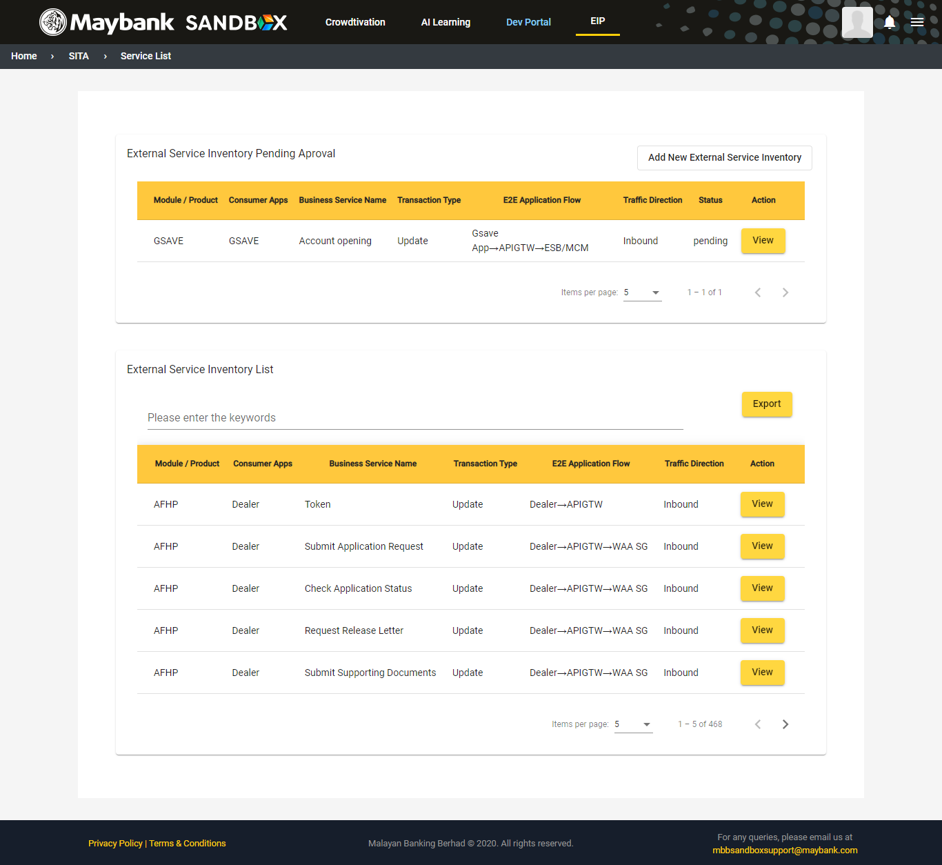

1. Once you click the button View, all the service details will be shown. Admin can reject or approve the request here. Admin can duplicate the whole detail contents by clicking the Create as New button. You can also edit any contents of the details via the Edit button. You can report any issues by clicking Report Issue button or submit your feedback via the Feedback button. Back button will redirect you to the external inventory list page.

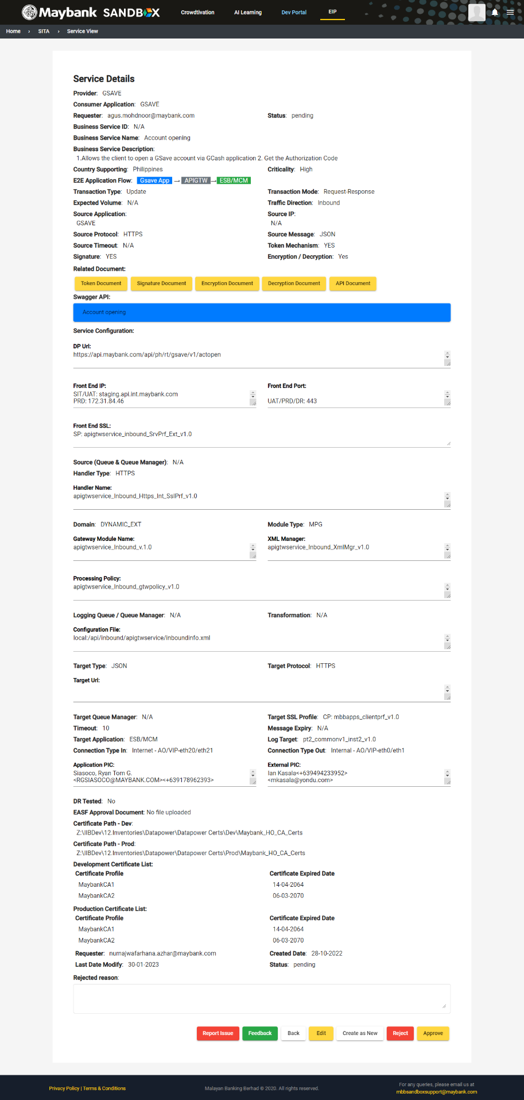

For team access

1. Once you enter the dashboard, you can see external service inventory list and rejected request. Your action is you can view the details by clicking the button View or you can add new internal service inventory. You can also search the inventory list by using the Search bar. You can also customize your view by choosing the drop down for items per page.

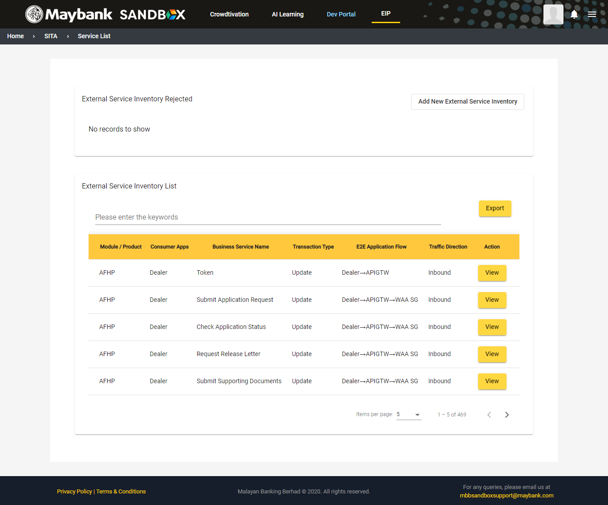

1. Once you click the button View, all the service details will be shown. You can duplicate the whole detail contents by clicking the Create as New button. You can also edit any contents of the details via the Edit button. You can report any issues by clicking Report Issue button or submit your feedback via the Feedback button. Back button will redirect you to the internal inventory list page.

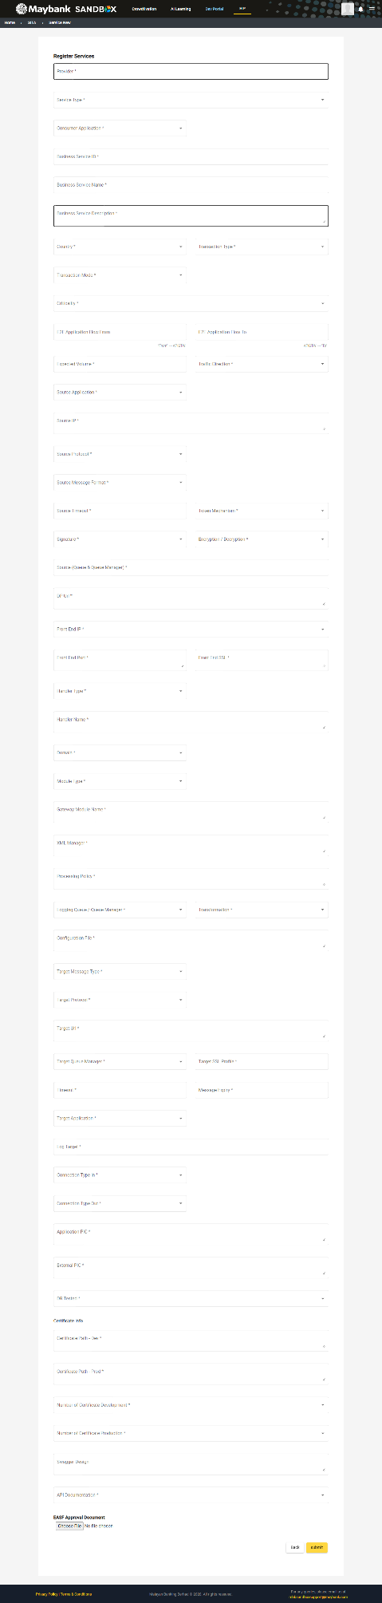

1. Once completed, the service details will be shown.

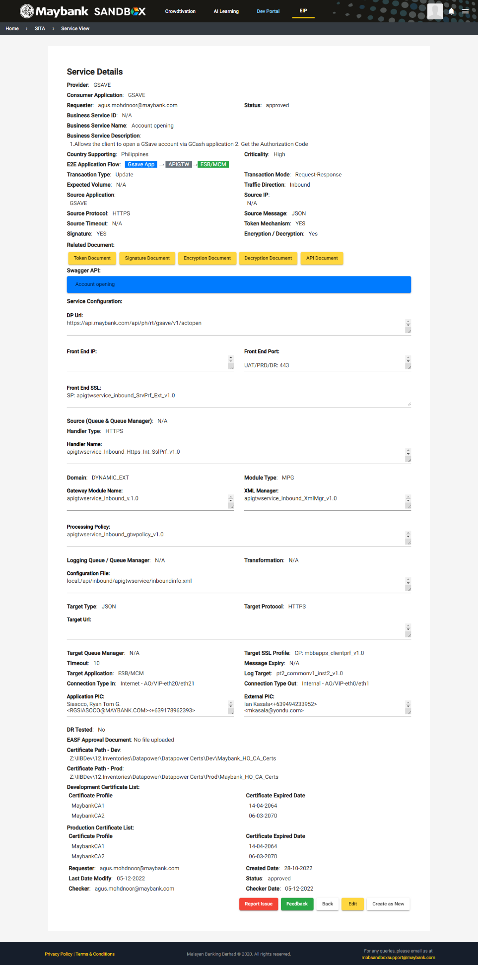

**Certificates**

For admin access

1. Once you enter the dashboard, you can see certificate list and approval request. Your action is you can view the details by clicking the button View or you can edit the certificates list. You can also customize your view by choosing the drop down for items per page.

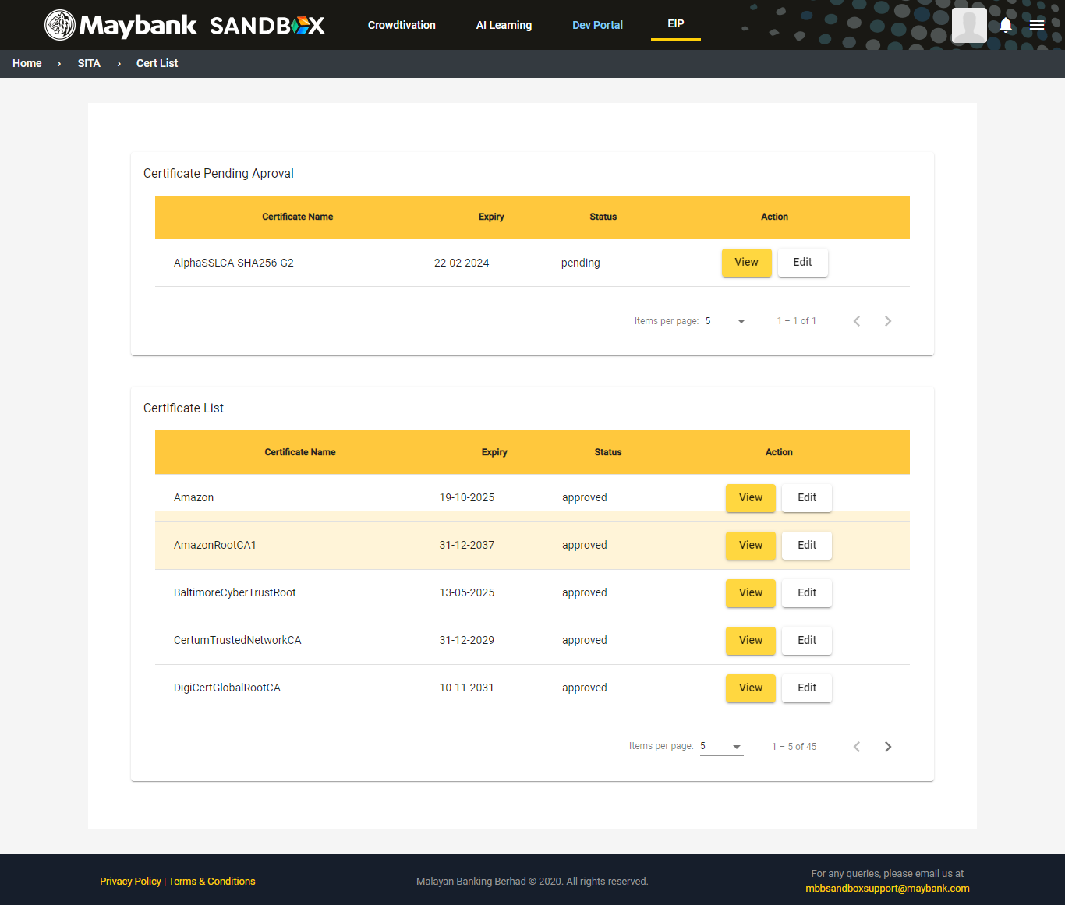

1. 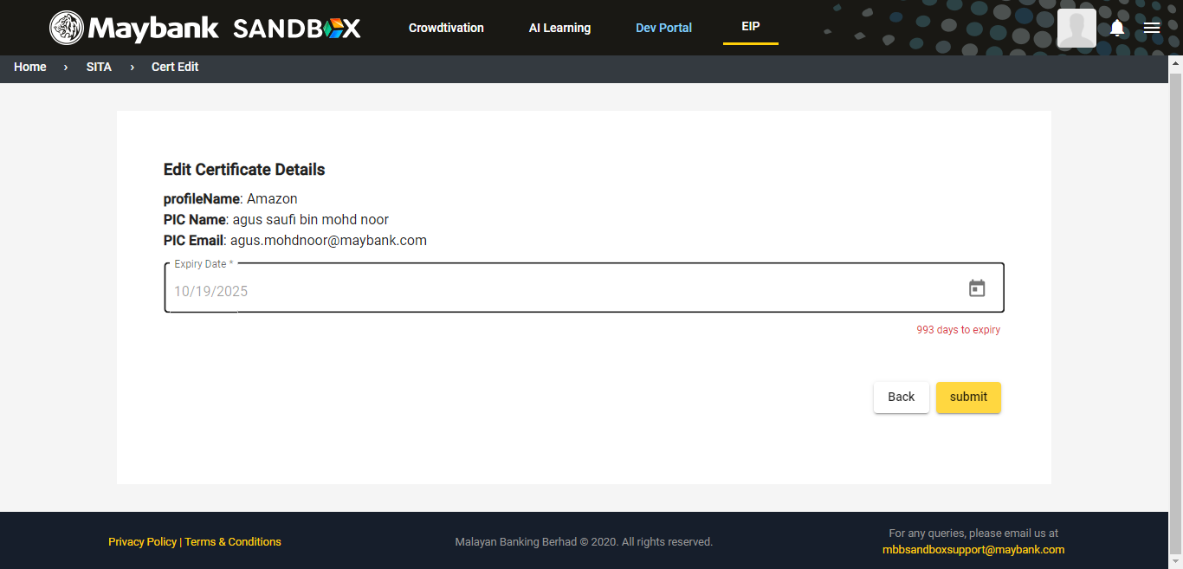Once you click the button View, all the certificate details will be shown. You can also edit any contents of the details via the Edit button.

For team access

1. 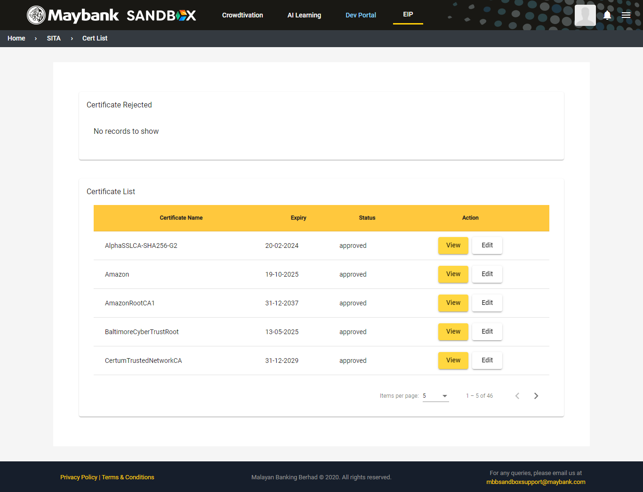Once you enter the dashboard, you can see certificate list and rejected request. Your action is you can view the details by clicking the button View or you can add new certificate list. You can also customize your view by choosing the drop down for items per page. Then, for rejected request, you can view it at the top of the dashboard.

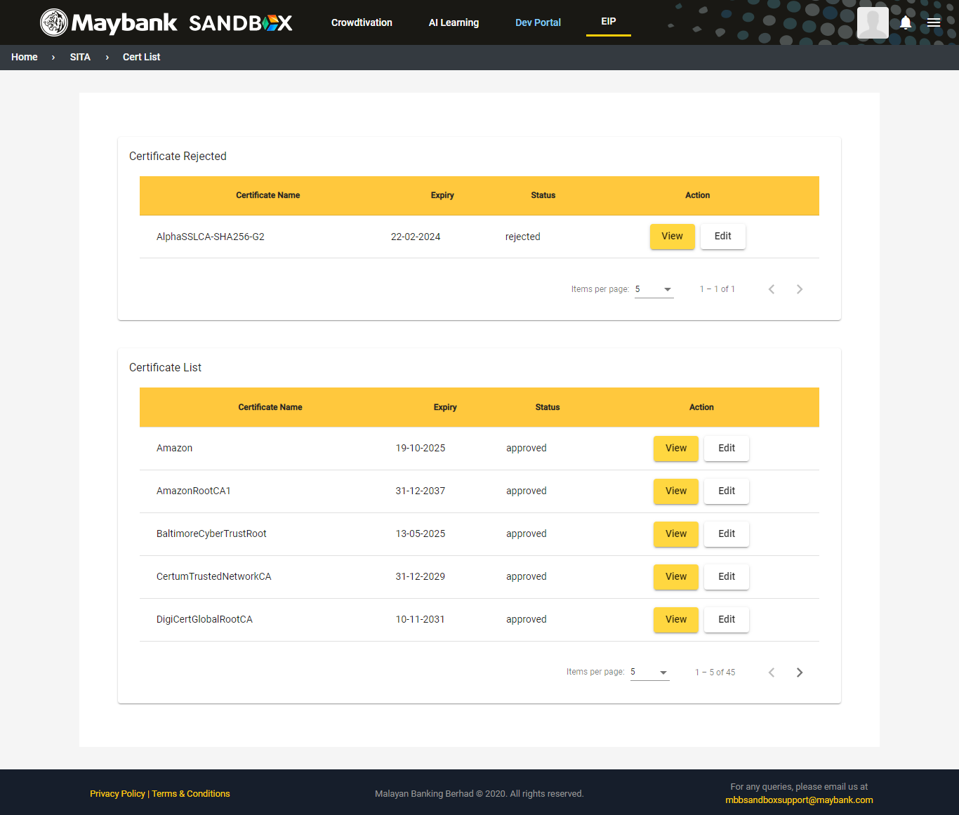

1. 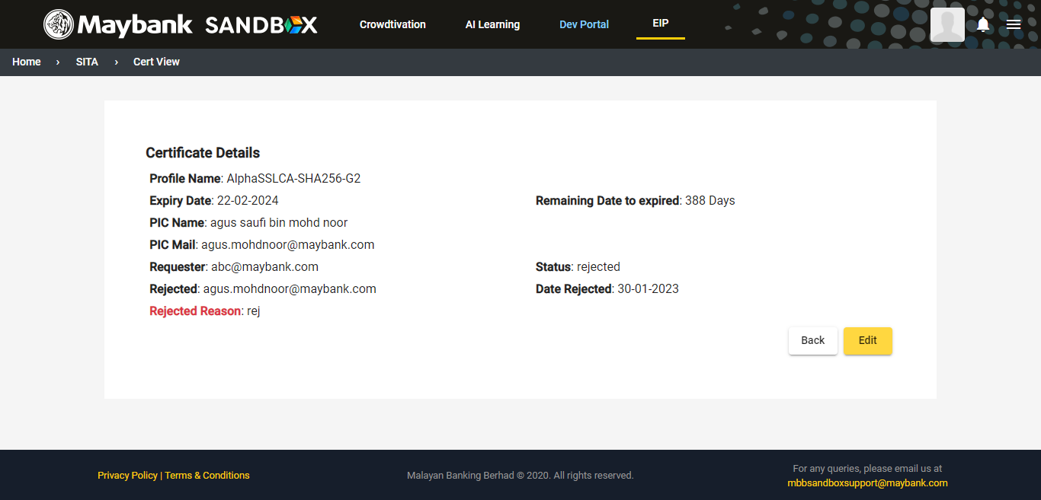When viewing rejected request, it will show rejected reasons and from this view, you can edit the details via Edit button.
2. Once you click View button, you can edit the expiry certificate date and click Submit.